Disable Windows Update service to stop Windows 10 update
Windows Update service can detect, download and install the Windows updates and programs. Once disabled, you can not use the Windows automatic update feature, and programs will not be able to automatic download and install.
Some people find it impossible to disable Windows 10 update in the Windows Update service, and the settings changes every time your computer starts installing the Windows update. It’s likely caused by Windows 10 Update Assistant. If that’s your case, you should completely uninstall Windows 10 Update Assistant in your computer first.
Once uninstall Windows 10 Update Assistant, you can start the steps below:
1) On your keyboard, press the Windows logo key + R at the same time to invoke the Run box.
2) Type services.msc and press Enter.
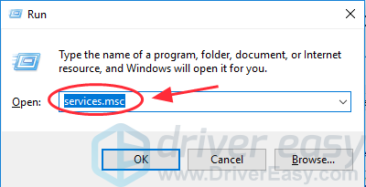
3) Scroll down to Windows Update, and double click it.
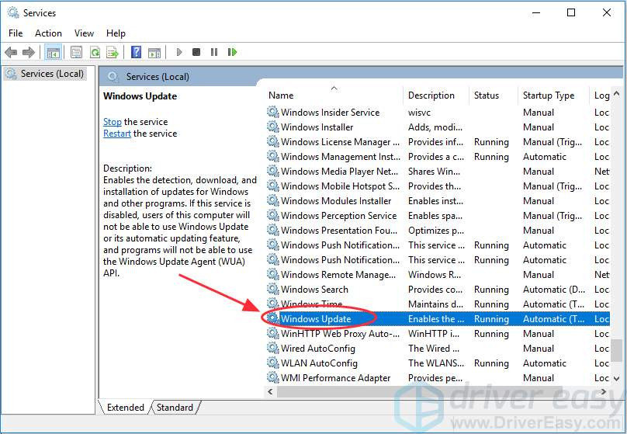
4) In Startup type, select Disabled. Then click Apply and OK to save the settings.
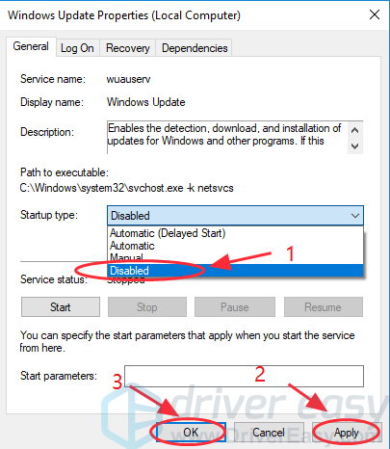
5) If it’s the first time that you stop the Windows Update service, you may also need to take one more step:
Still on the Windows Update Properties pane, click the Recovery tab, select Take No Action in the First failure section, then click Apply and OK to save the setting.
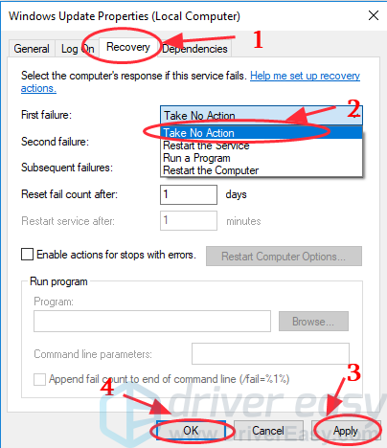
6) Restart your PC to make it take effect.
Note: If you disable the Windows Update service, your computer will not be able to download the updates. When you manually click to update, you will see a message that updates were not installed because computer was stopped. So if you want to update your Windows 10, you can go to the Windows Update service, and select Automatic to enable the service. Then you will be able to update your Windows.

